LITERATURE SURVEY
EXPLORATORY ANALYSIS OF RAINFALL
DATA IN INDIA FOR AGRICULTURE

- Xiaobo Zhang;Sachi Nandan Mohanty;Ajaya Kumar Parida;Subhendu Kumar Pani;Bin Dong;Xiaochun Cheng. Annual and Non-Monsoon Rainfall Prediction Modelling Using SVR-MLP: An Empirical Study From Odisha. (IEEE)(2020)
- Shilpa Manandhar;Soumyabrata Dev;Yee Hui Lee;Yu Song Meng;Stefan Winkler A Data-Driven Approach for Accurate Rainfall Prediction. (IEEE)(2019)
- Nana Kofi Ahoi Appiah-Badu;Yaw Marfo Missah;Leonard K. Amekudzi;Najim Ussiph;Twum Frimpong;Emmanuel Ahene Rainfall Prediction Using Machine Learning Algorithms for the Various Ecological Zones of Ghana.(IEEE)(2021)
- Deepali Patil Shree L.R.Rainfall Prediction using Linear approach & Neural Networks and Crop Recommendation based on DecisionTree.(IEEE)(2020)
- A. Haidar, B. Verma.Monthly Rainfall Forecasting Using One-Dimensional Deep Convolutional Neural Network(IEEE)

Problem Statement:
- Rainfall has been a major concern these days. Irregular heavy rainfall may lead to the destruction of crops, heavy floods that can cause harm to human life.
- It is important to exactly determine the rainfall for effective use of water resources, crop productivity, and pre-planning of water structures.
Objective:
- We will be using classification algorithms such as Regression, Decision tree, Random forest, KNN, and xgboost. We will train and test the data with these algorithms.
- From this best model is selected and saved in pkl format.
- Once the model is saved, we integrate it with flask application and also deploy the model in IBM.
Work Plan
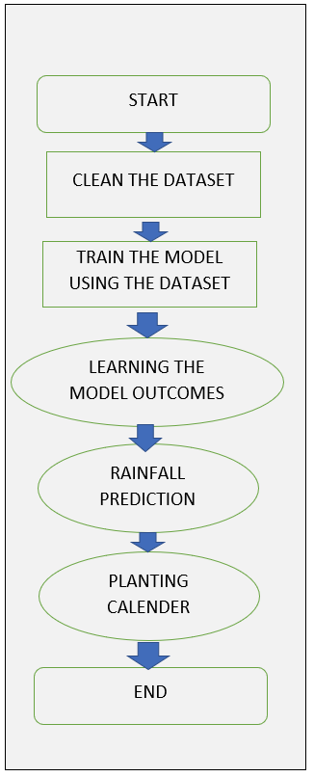

FLOW DIAGRAM TO TRAIN THE MODEL
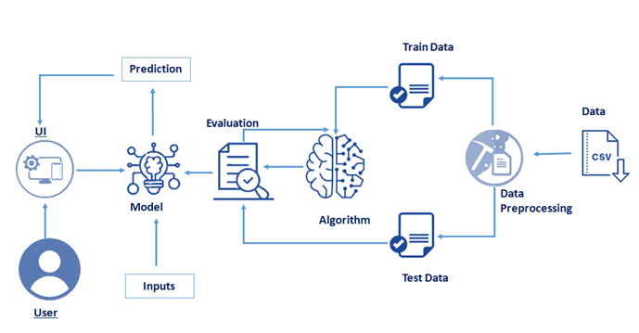
Conclusion
- The dataset consist of measurement of the rainfall in various State’s of India which ranges from January to December and also consist of overall annual rainfall for the respective States
- With the help of this dataset we can easily predict the upcoming rainfall measurement
- So that we can easily predict the agricultural status with the help of the rainfall measurement in the respective State’s

